Assignment 3 (170 points)
Due 11:59 pm on Friday May 22nd, 2026
Question 1
- (25 pts) Centered 3 x 3 Phantom.
  - (2 pts) Display the image.
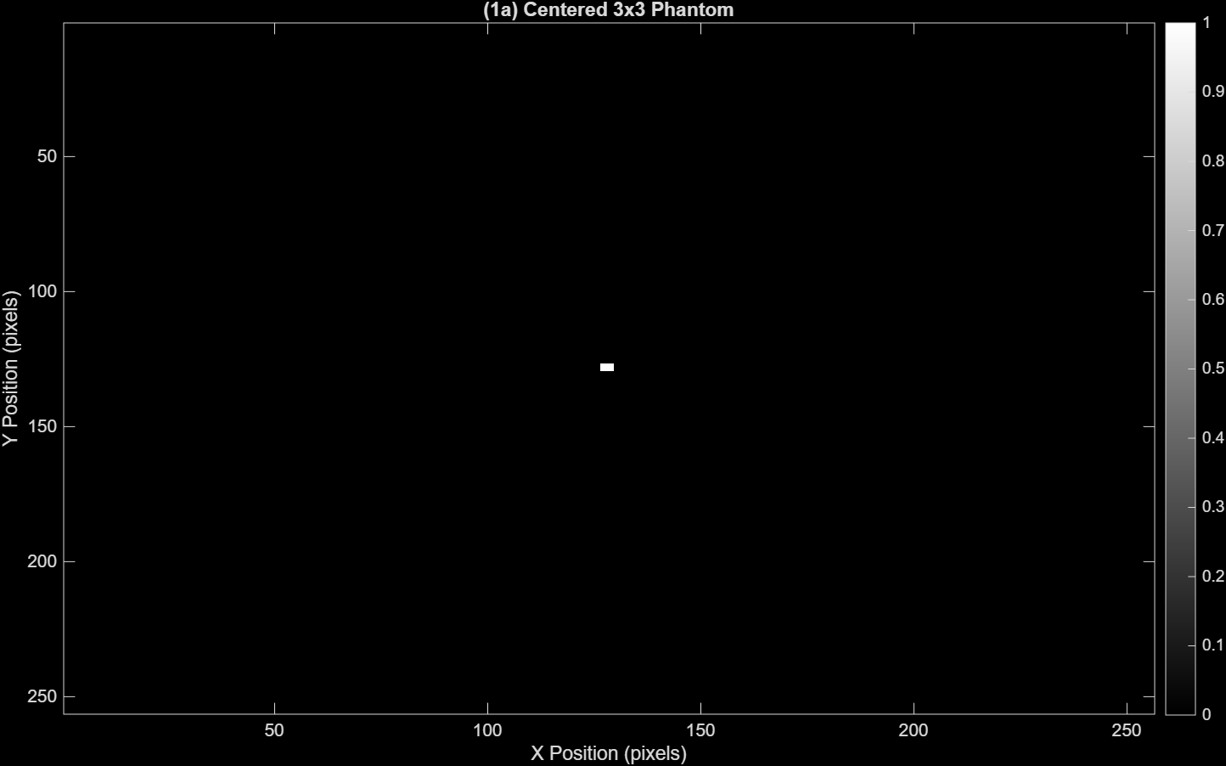
  - (4 pts) Mark the 90-degree projection on the image, with the positive arrow pointing in the direction of increasing detector length.
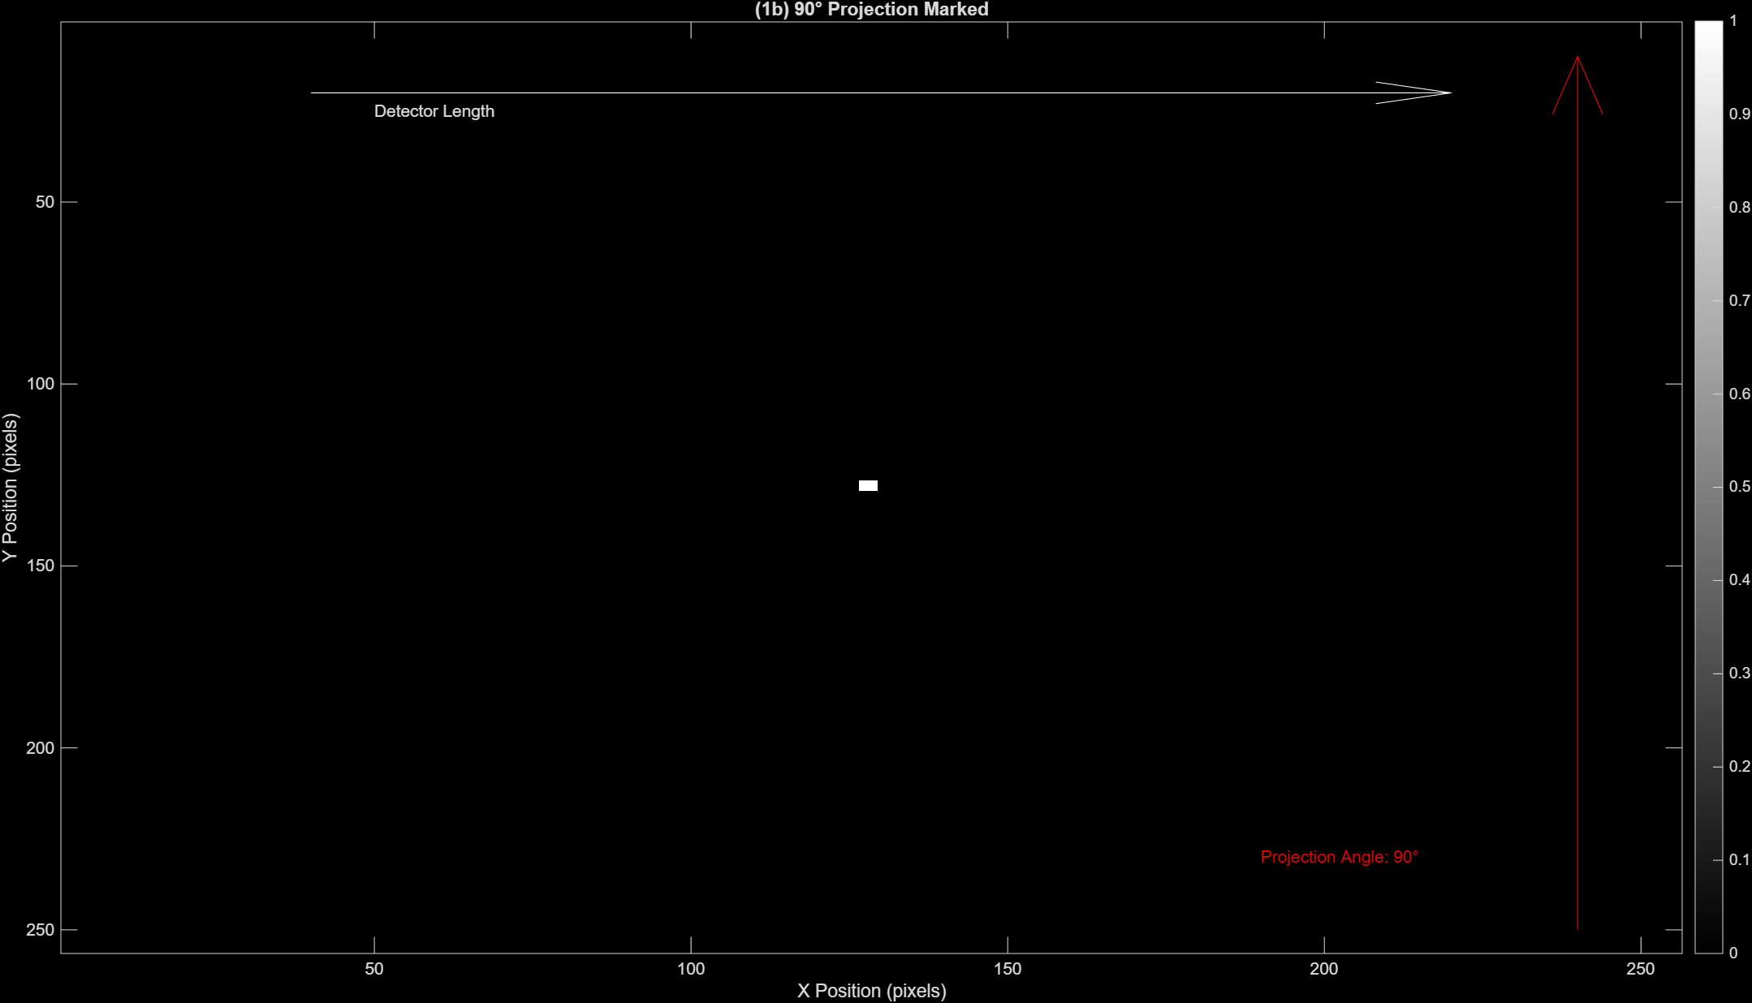
  - (3 pts) Sketch the theoretical projection profile, labeling axes values appropriately. A hand sketch or digital version is acceptable.
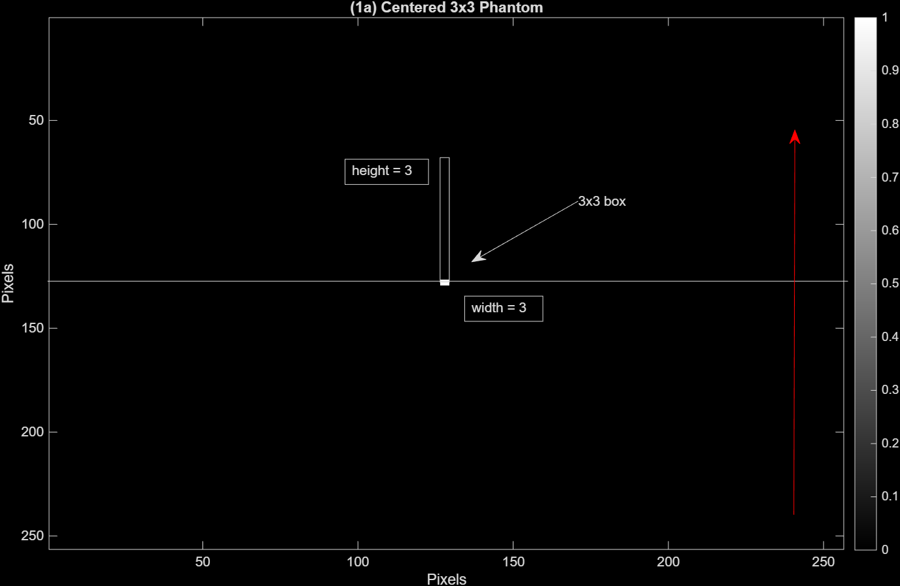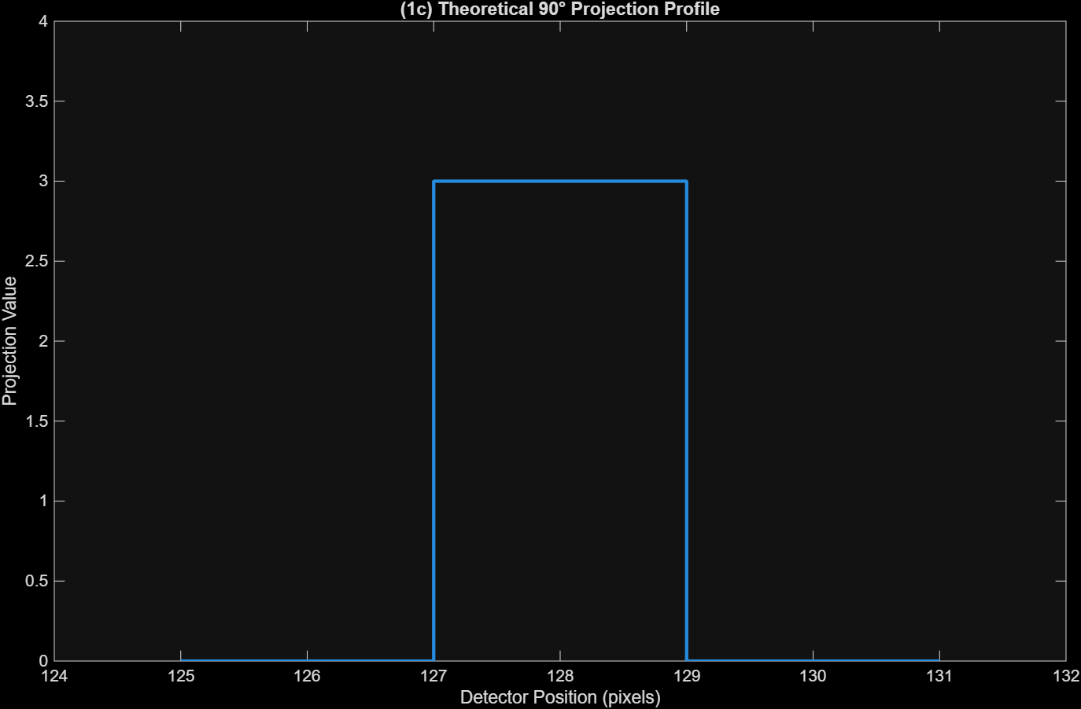

  - (3 pts) Use the radon function to generate the sinogram and display it.
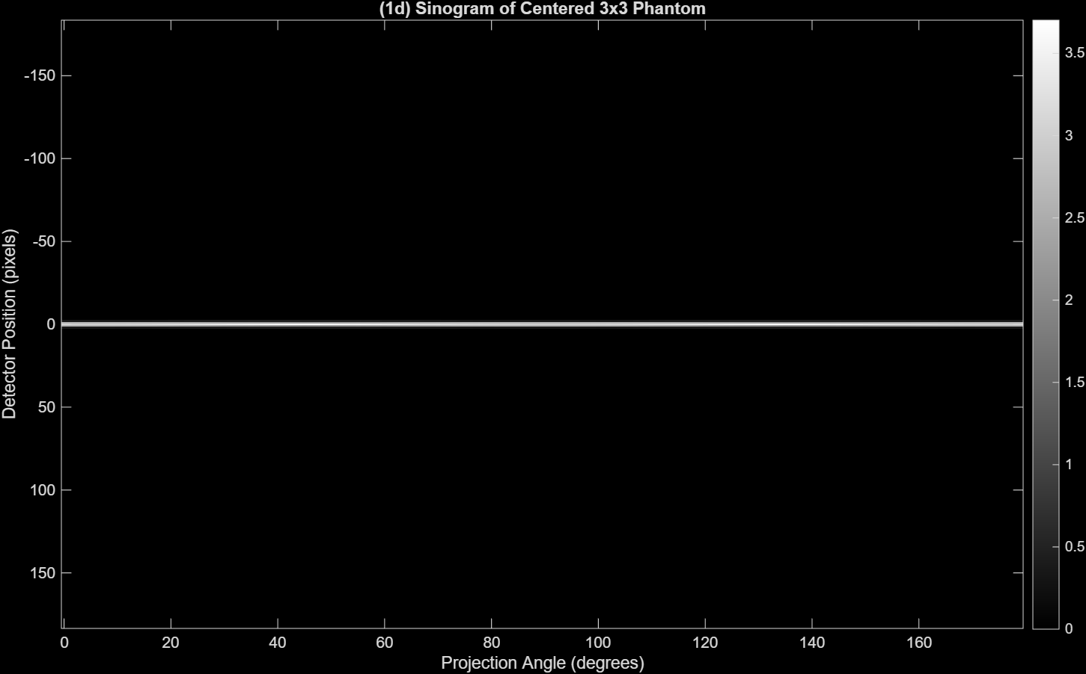
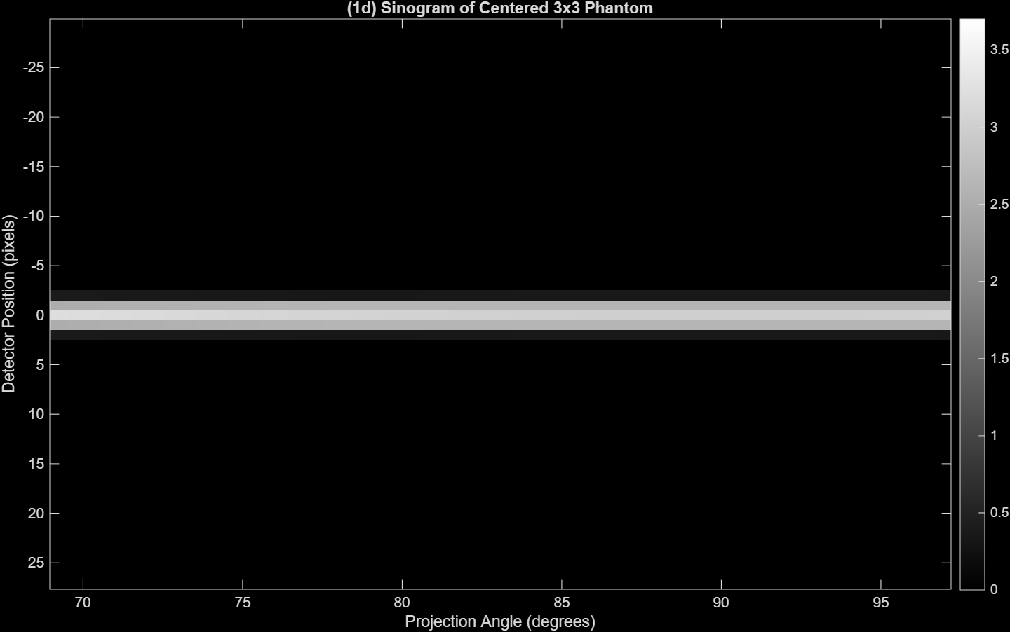

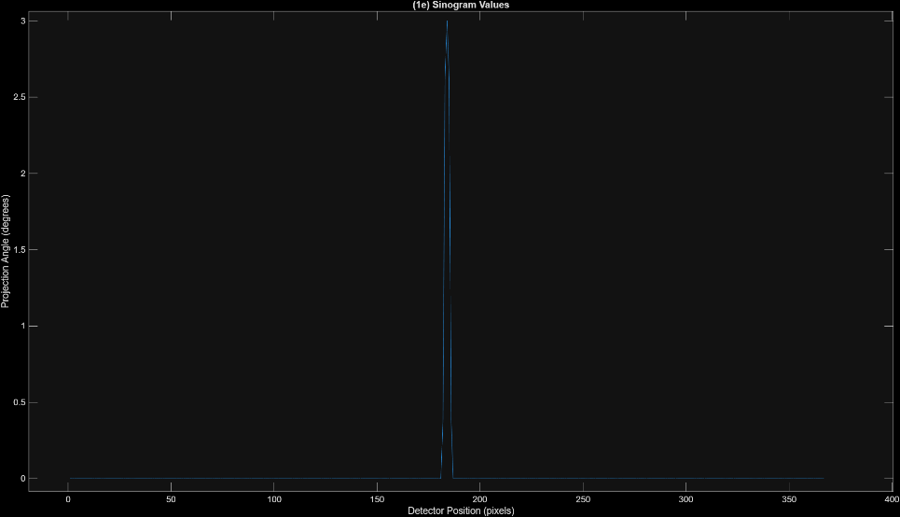
  - (4 pts) Report the sinogram values for the 90-degree projection. Do the values match your theoretical prediction? Explain your reasoning.
Detector Position | Projection Value
182 | 0.3750
183 | 2.6250
184 | 3.0000
185 | 2.6250
186 | 0.3750

    - The values of the sinogram for the 90-degree projection almost match the theoretical projection where the center position of the 3x3 block has the max projection value of 3. However, the edge values on either side of the box decrease in value which is probably caused by interolation effects when the radon() function maps discrete pixels to the positions as seen when graphing the points on a line plot. Overall, the signal is concentrated in the same region as what was predicted even though it doesn’t properly maintain that rectangular box look with constant values of 3 when the beam passes through the phantom.

  - (9 pts) Calculate and report the sum of pixel values in the original image. Next, calculate and report the sum of values in the 0-degree, 90-degree, and 180-degree projections from the sinogram. What pattern do you notice? What does this tell you about the radon transform?
    - Sum of pixel values in original image: 9
    - Sum of values in the 0 degree: 9
    - Sum of values in the 90 degrees: 9
    - Sum of values in the 180 degrees: 9
    - In every degree projection, the sum of pixels has a value of 9. This tells us that the radon transform preserves the total integral of the original image so in looking at it from the horizontal axis (0 and 180 degrees) or the vertical axis (90 degrees), the 3x3 phantom always projects the same sum of pixel values along those lines even though its distribution across the detector changes.
This also makes sense mathematically since each projection is the integral of the attenuation along the X-ray path [ g(l,θ) = ∫ μ(s; E)ds].
Question 2
- (20 pts) Phantom with Multiple 3x3 Blocks
  - (1 pts) Display the image.
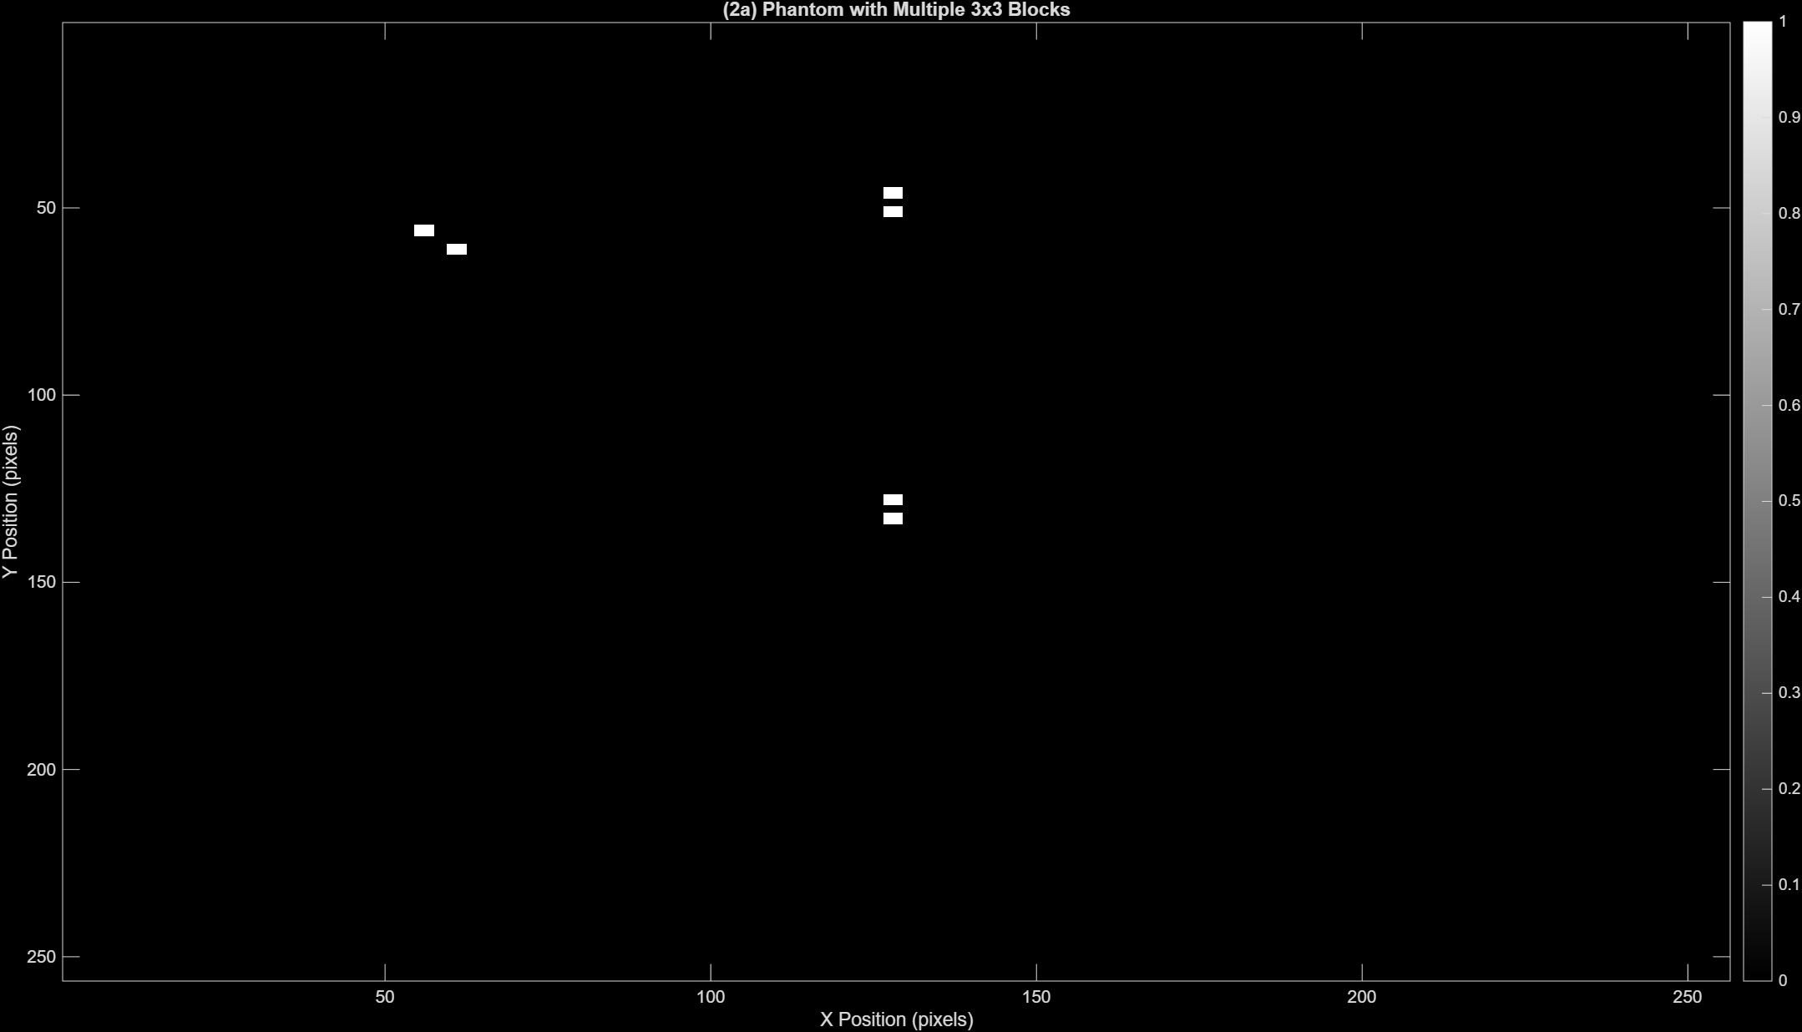
  - (3 pts) Generate and display the sinogram using radon.
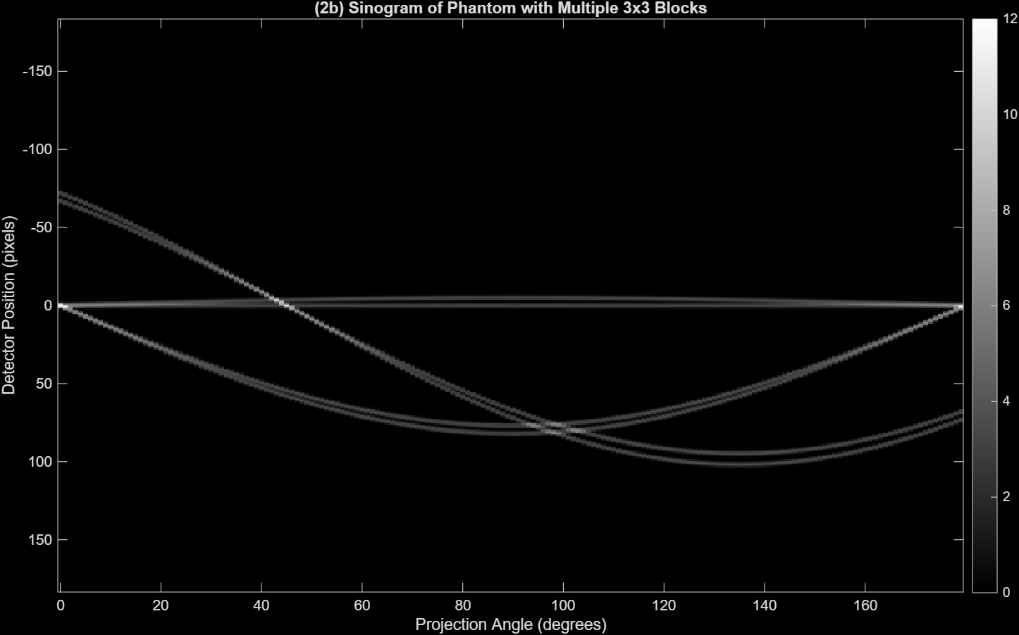
  - (8 pts) Explain the key visual features of the sinogram at 0-, 45-, 90-, and 180-degree projections.
    - At 0, 45, 90, and 180 degrees of the sinogram, there are points with a much higher contrast at specific detector positions. This is caused by multiple blocks aligning along the projection direction, so they build at the same detector positions, intensifying that area, causing higher intensity regions in the sinogram.
Focusing on specifically 0 degrees and 180 degrees, the projections are taken along the horizontal direction. Since all of the phantom blocks have similar X-coordinate positions, they line up vertically so at these angles the beams move horizontally and the blocks at the same Y coordinate project onto the same detector position.
At projection angles of 90 degrees, 4 bright spots are positioned in a diamond formation. At this angle, the projection is taken along the vertical direction and because the phantoms have different Y coordinates, they separate into distinct spots based on their position.

  - (8 pts) Label the 0, 45, 90, and 180 projections on the phantom image, with arrows indicating the positive detector direction.
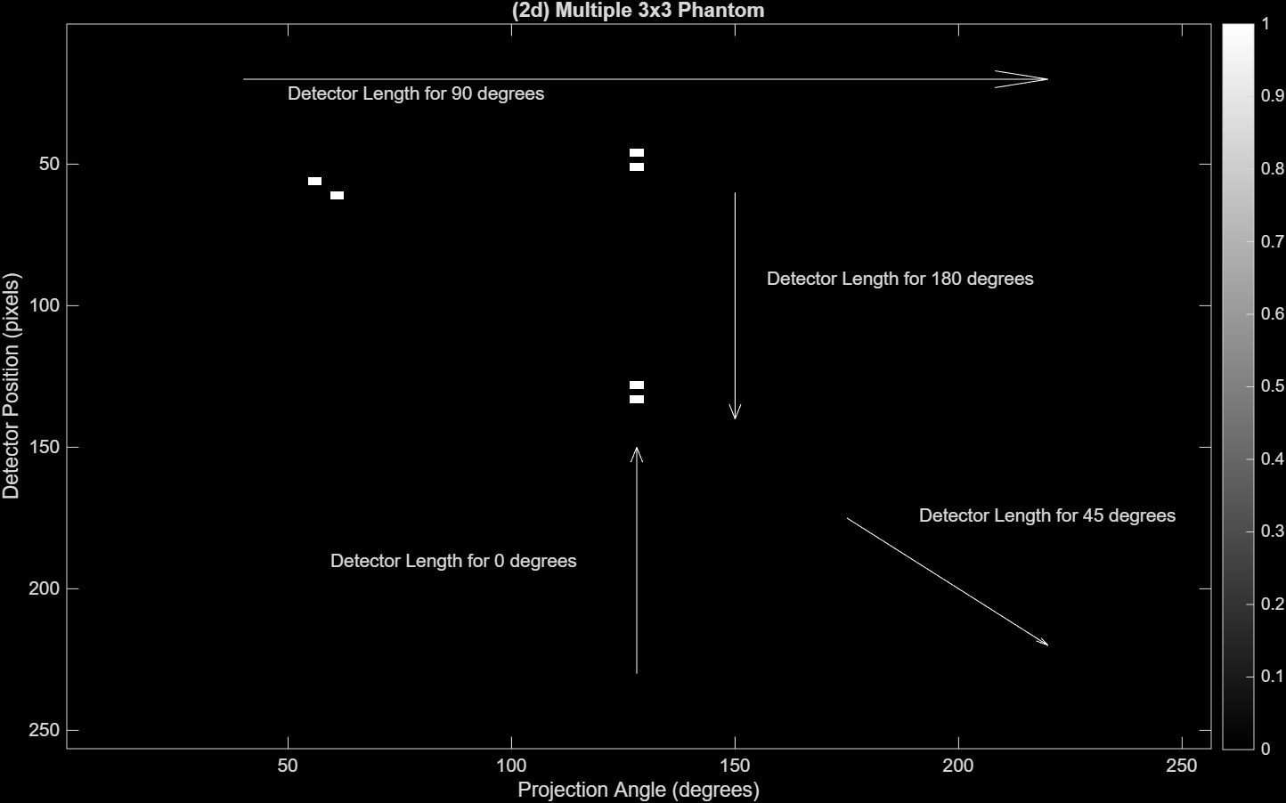

Question 3
- (20 pts) Simple and Filtered Back projection.
  - (2 pts) Use iradon with filter ‘none’ to generate a simple back projected image. Attach the image.
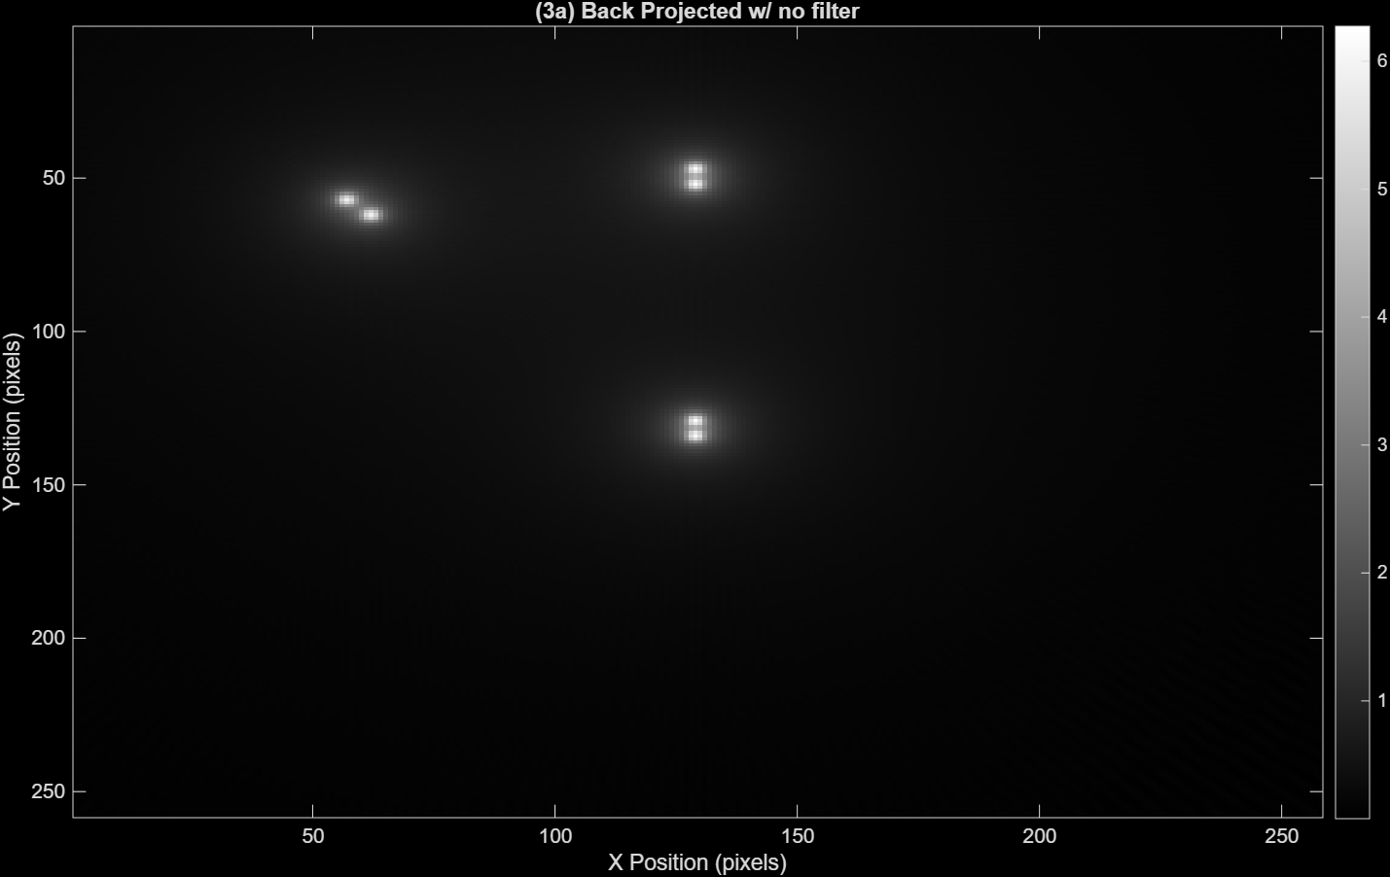
  - (4 pts) Visually describe key differences between the simple back projected image and the original phantom image (from 2a), focusing specifically on the background and the small blocks.
    - The small blocks now have an aura surrounding them which is creating a glowing halo effect instead of having sharp edged squares. Overall, the blocks just appear more blurred and spread out with bright streaks emitting from them in all directions. This also changes the background since the original picture was pure black but the glow of the blocks fills parts of the empty space which ruins the contrast of the phantoms to the background.

  - (2 pts) Perform a filtered back projection using the ‘Ram-Lak’ filter. Attach the image.
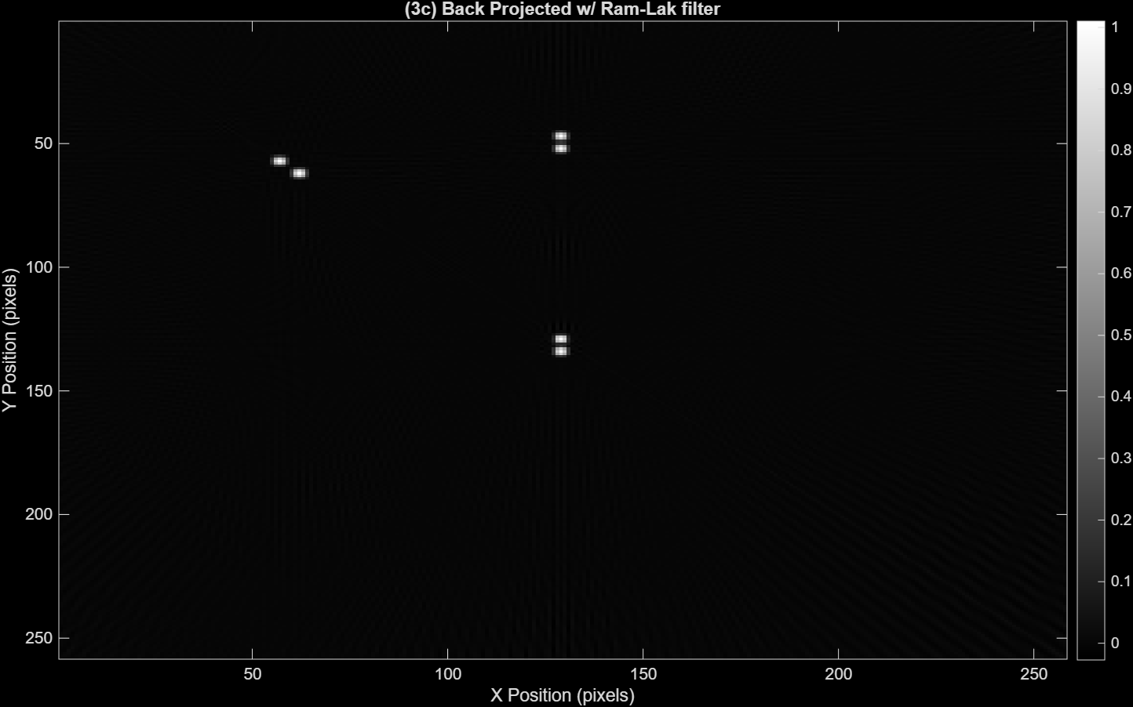
  - (4 pts) Visually describe differences between the simple (from 3a) and filtered back projected (from 3c) images, focusing on the background and small blocks.
    - The Ram-Lak filter improves the glowing or blurring that was surrounding the blocks, so they are more compact and more distinguishable even if it is not as one to one to the original image where the edges have a much clearer distinction. The background also improved where it’s a lot darker and there are no halos but now there are light vertical streaks appearing near the blocks. It’s not as noticeable and doesn’t really affect the look of the phantom.

  - (2 pts) Repeat filtered back projection using the ‘Hann’ filter. Attach the image.

  - (4 pts) Visually describe key difference(s) between the ‘Ram-Lak’ and ‘Hann’ images.
    - The Hann filter mainly affected the visualization of the phantoms where the blocks now look more rounded or blurred in a way. However, the background has improved immensely where there are no noticeable noise or streaks so its pure black all around.
  - (2 pts) Quantify the root mean square error (RMSE) of the ‘Ram-Lak’ and ‘Hann’ images with respect to the original phantom image.
    - RMSE Ram-Lak: 0.0251
    - RMSE Hann: 0.0228

Question 4
- (35 pts) Shepp-Logan Phantom
  - (2 pts) Create and display a 256 x 256 image of the Shepp-Logan phantom.
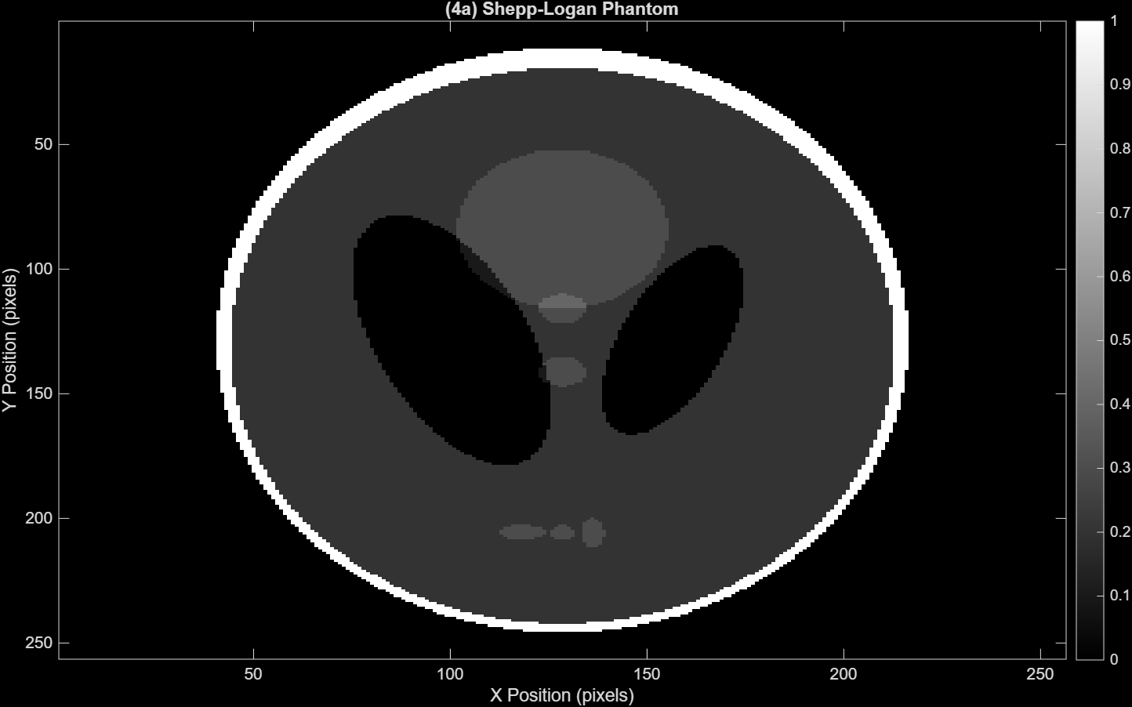
  - (3 pts) Generate the sinogram using radon with a projection acquired every 1 degree. Display the sinogram.
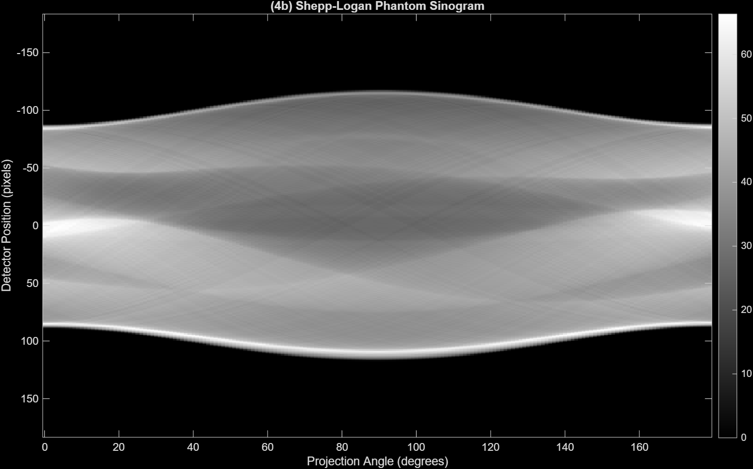
  - (2 pts) Reconstruct the image using iradon and the ‘Ram-Lak’ filter. Display the filtered back projected image.
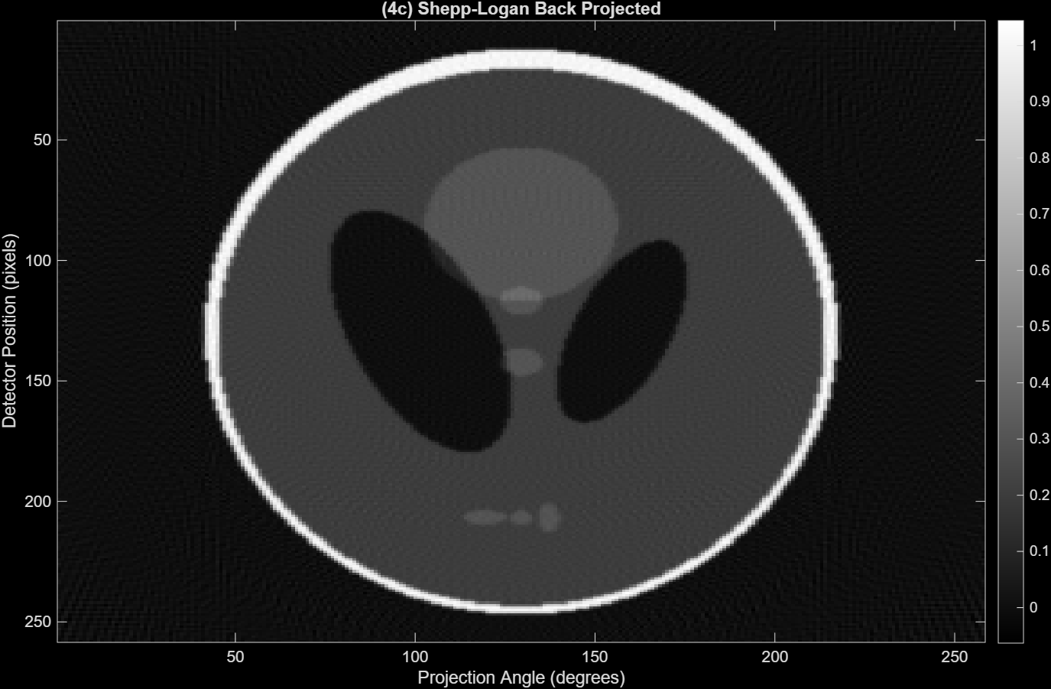
  - (25 pts) Propose and explain two possible methods by which you can reduce the radiation dose by a factor of 10. For each, attach the resulting sinogram and reconstructed image. Which method would you choose and why?
    - To reduce the radiation dose by a factor of 10, we can increase the step size of the projections to every 10 degrees instead of 1 so it only gives 18 projections instead of 180. The sinogram will still span the full 180 degree ran but will appear blockier and have more artifacts or gaps due to the smaller sampling as seen below.
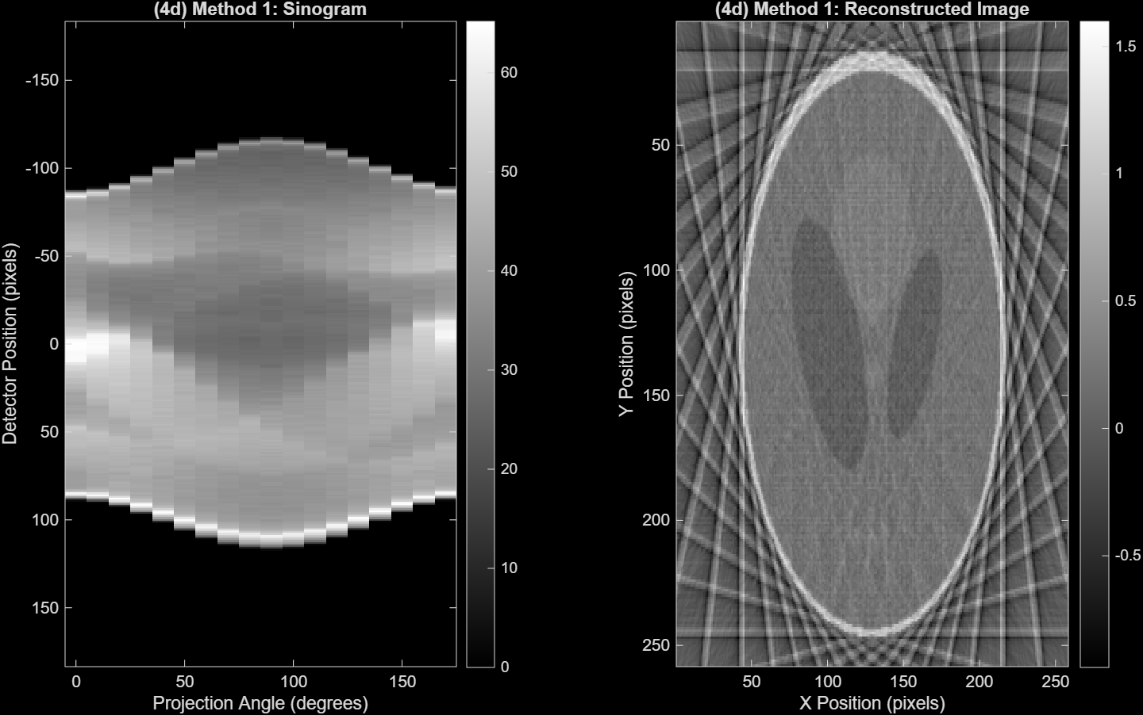
    - Another method to reduce the dose by a factor of 10 is possibly decreasing the angular range to a span of 18 degrees instead of 180 but keeping the step size to 1 degree. What is captured will be very narrow and limited since it covers a much smaller window but in theory would decrease artifacts and gaps. As seen below though, the phantom is unrecognizable and blurry.
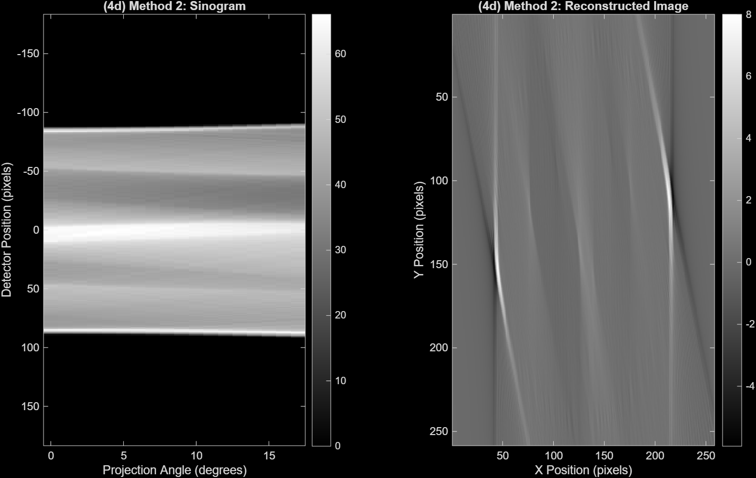

    - Method 1 is the better choice. While it does produce streak artifacts in both the phantom and the background, the overall structure of the phantom is still visible. Method 2 removes entire projection viewpoints, so a lot of information is missing. Because of that, the reconstruction ends up looking really distorted and it’s hard to make out anything useful or recognizable.

  - (3 pts) From the experiment above, estimate the position of the x-ray source at θ = 0°, and determine if its direction of rotation is clockwise (CW) or counterclockwise (CCW). Provide your reasoning. Feel free to experiment with the theta vector to assist your explanation.
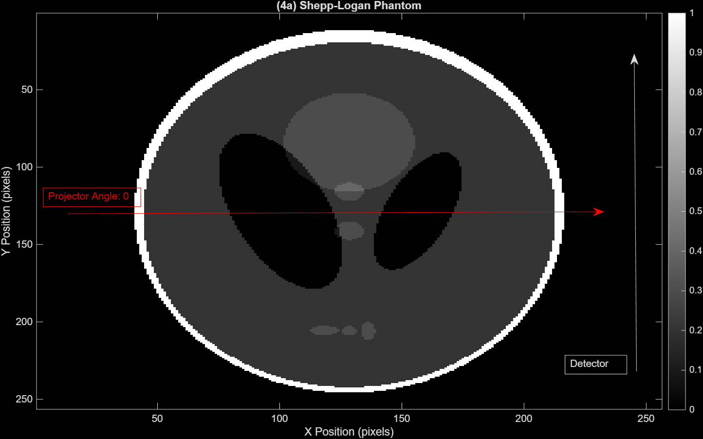
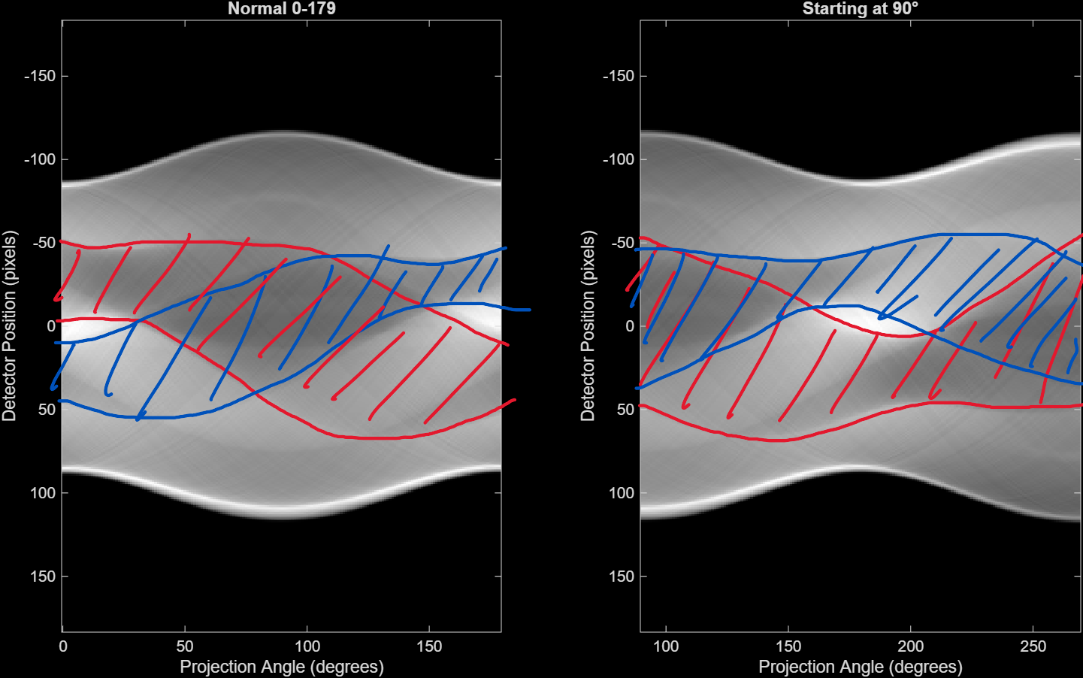
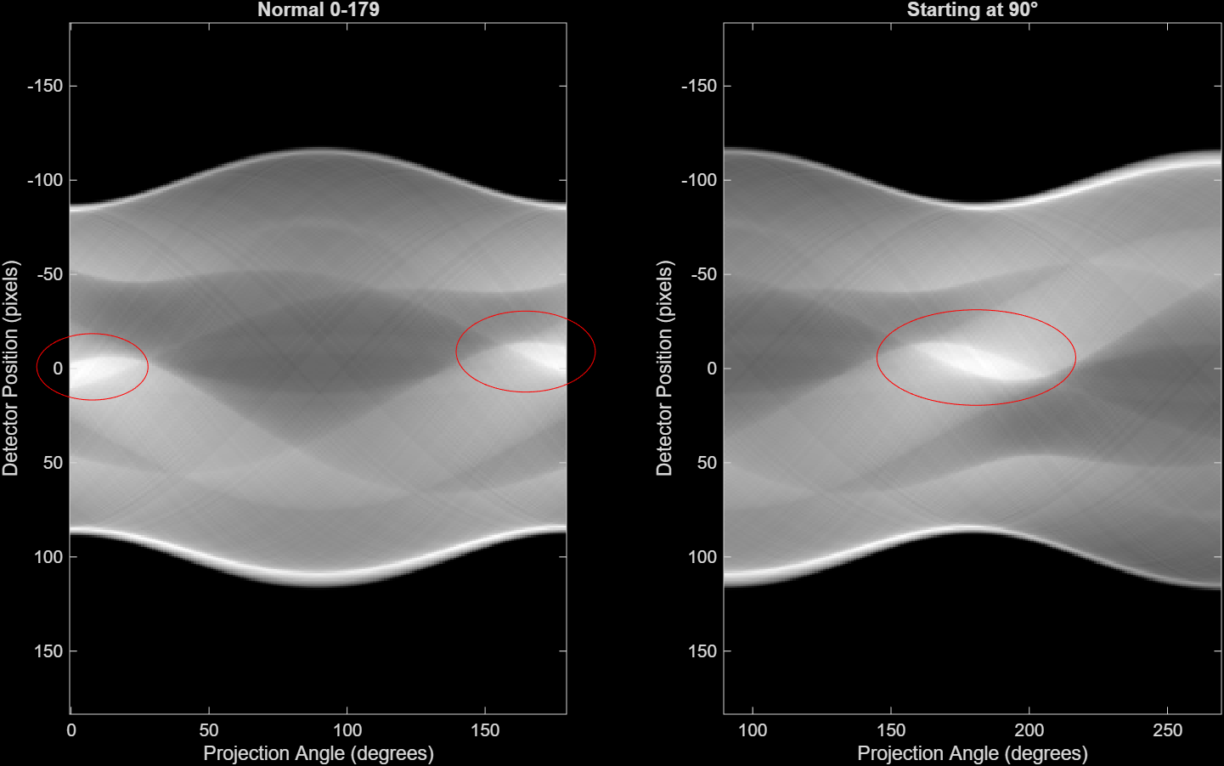
    - Focusing on the phantom first it has multiple key features that would appear in the sinogram:
      - Bright white outline around the phantom where the top is much thicker than the bottom.
      - Two large black oval regions where the left oval is larger than the right.
      - Light grey circular/eclipsed internal structures that are less prominent.
At 0 degrees, assuming the X-ray source is on the left side of the phantom, with the detector placed vertically on the right side as seen in the first image above. The X-rays should travel horizontally from left to right through the phantom. To prove this, I graphed the sinograms starting at 0 degrees and 90 degrees and annotated out different features.
In tracing the paths of the two large black ovals within the phantom (shown in red and blue curves in image 2), they start thick at the top edge and gets thinner, while the blue curve (representing the smaller right oval) starts thin at the bottom edge when the angle starts at 0 degrees (panel 1). This makes sense since the X-rays travel horizontally left to right, so they pass through the widest part of the left oval first, creating the thick section of the red curve at the top of the sinogram.
When I changed the theta vector to start at 90 degrees instead (second panel) those same red and blue curves shifted to the right in the sinogram. Now the plot starts with the thick sections of both curves which makes sense because at 90 degrees the X-ray source is at the bottom shooting upward, so it passes through the horizontal cross-section of both ovals at their widest points.
The third image shows the bright white internal structures circled. At 0 degrees (panel 1), these bright spots appear at the left and right edges of the sinogram. But when it starts at 90 degrees, they shift to the center. This movement from edges to center confirms that the source rotated counterclockwise from the left side (0°) to the bottom (90°).
Overall, this confirms the rotation is counterclockwise (CCW) because as theta increases from 0 to 90 degrees, the phantom features shift positions in the sinogram exactly how they would if the X-ray source rotated counterclockwise.
Question 5
- 5. (60 pts) Effect of Measurement Noise
  - (20 pts) Using the Shepp-Logan sinogram from 4(b), add six different noise levels: 0.05, 0.10, 0.15, 0.20, 0.25, 0.30 (corresponding to 5%, 10%, 15%, 20%, 25%, and 30%, respectively).
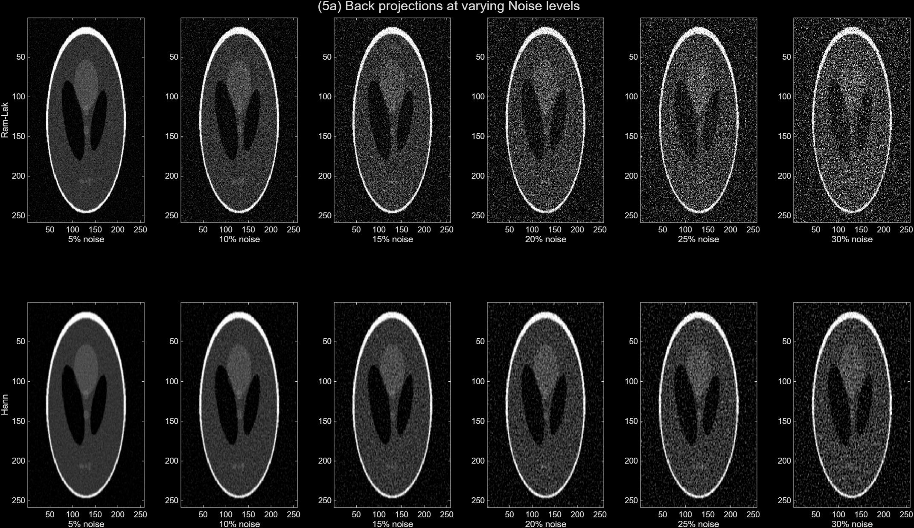
What do you notice about these two sets of images as noise increases? If you were a radiologist, which filter would you prefer and why?
    - Both sets of images show increased graininess as noise increases but if I were a radiologist, I would prefer the Hann filter because it produces a much smoother image with less visible distortion than Ram-Lak. Ram-Lak overall does develop more sharper features than Hann, but it has more streaking artifacts that then affect the overall color as well where there is no differentiation between the background and the phantom. Hann overall has more distinguishable features despite the noise and the slight blur.

  - (10 pts) Plot a graph of the SNR values as a function of noise level for both the ‘Ram-Lak’ and ‘Hann’ images.
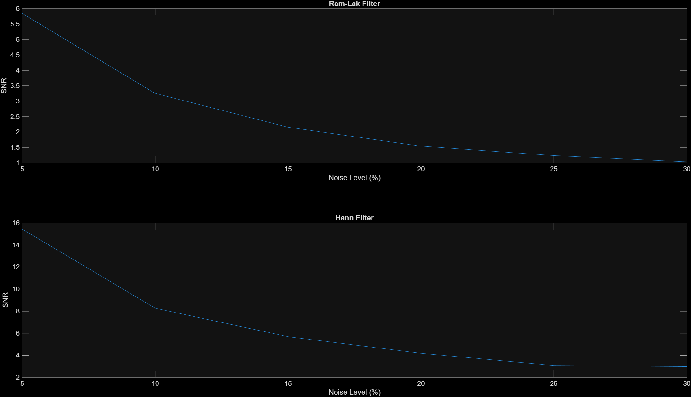
  - (12 pts) Now let’s try suppressing the noise in the sinogram measurements before performing the reconstruction. For each noise level, smooth the noisy sinogram using a simple 5×5 averaging kernel before reconstructing the image.
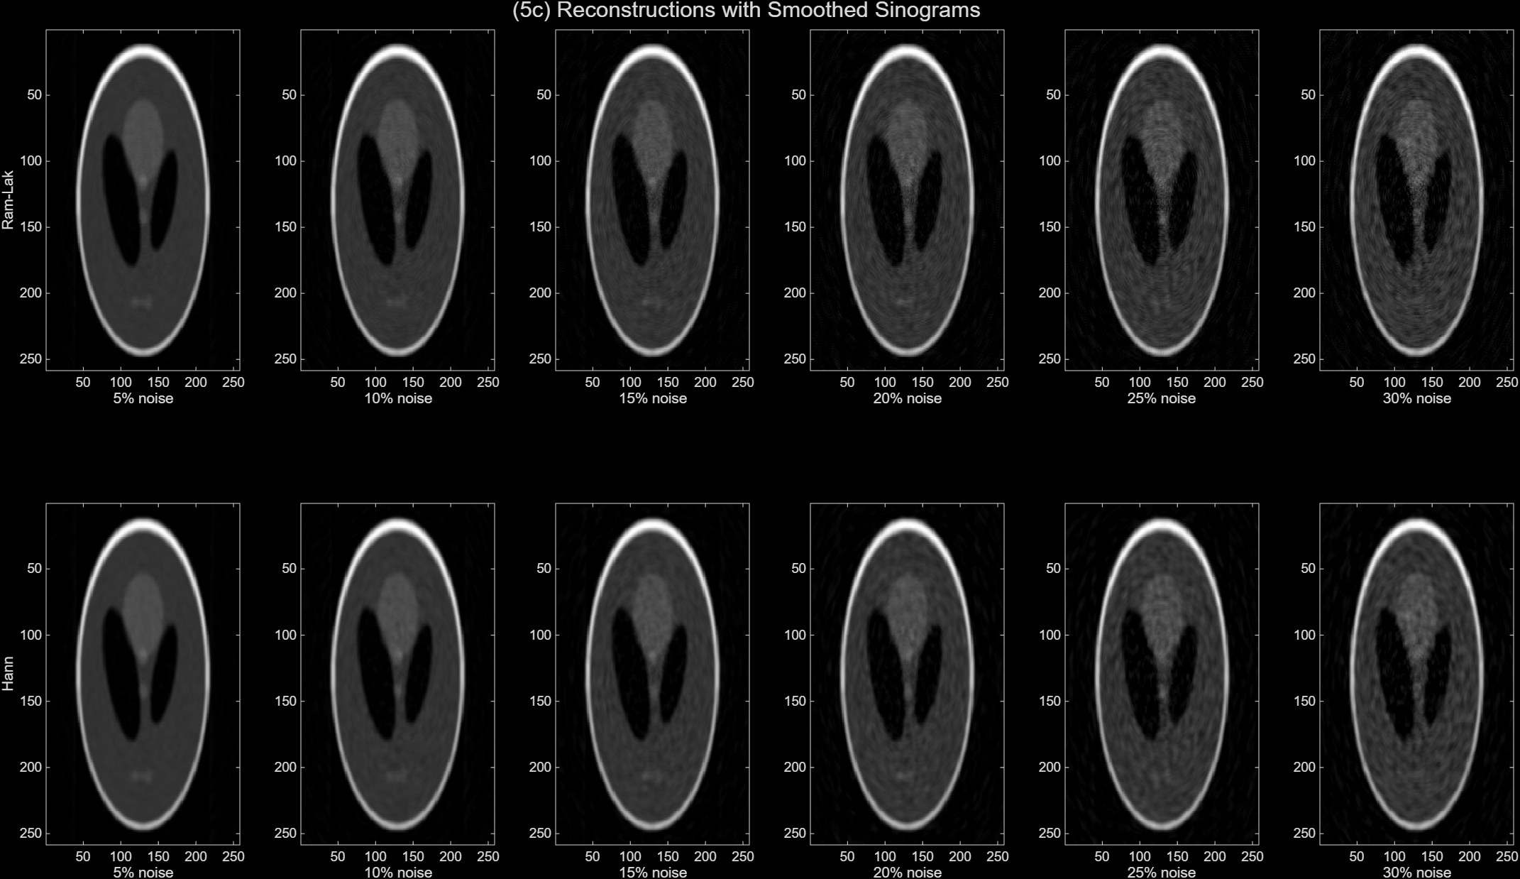
  - (10 pts) Repeat the SNR calculation for the smoothed cases, for both 'Ram-Lak' and 'Hann' reconstructions. Attach the SNR vs noise level plot.
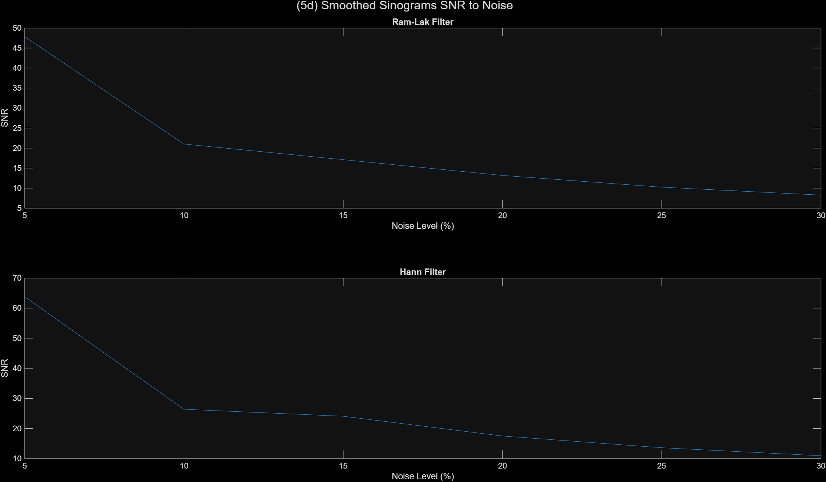
  - (4 pts) What is your main takeaway from this experiment about smoothing the sinogram?
    - Smoothing the sinogram before reconstruction reduces the noise in the final image as seen in the SNR to noise curves where the smoothed images have a much higher SNR at all levels of noise. The biggest issue is the quality or spatial resolution of the reconstructed image where the smoothed reconstructions appear blurrier than the unsmoothed ones especially when the features become smaller.

  - (4 pts) The smoothing operation has seemingly created a concentric circular texture around the image (more clearly visible in the higher noise level images). Can you explain the origin of this artifact?
    - The concentric circular artifact comes from how the sinogram is smoothed and then back projected. When we apply the 5×5 averaging kernel, we are doing a local average over both the projection angles and detector positions. This mixes neighboring values together and creates correlations in the sinogram that wouldn’t normally be there, instead of having independent line measurements.
During back projection, each detector value is spread back across the image along lines for all the projection angles. Because of this, a single detector position ends up contributing to multiple different directions in the image. Over all angles, these contributions form that circular pattern centered at the isocenter, which matches what we saw in lecture for ring artifacts where errors tied to a detector channel show up as circles in the reconstructed image.
Overall, when the sinogram has been smoothed, the values at each detector position already contain averaged information from neighboring positions. During back projection, these wrong values get repeatedly spread along all angles, so instead of staying local, the errors accumulate in a circular path.

Appendix: MATLAB Code
* Key note: Some of the images were adjusted in the MATLAB Figures extension.
%% Question 1 Part A
N = 256; % image size
img = zeros(N); % matrix of zeros
% Defining a small rectangle in the center
img(127:129,127:129) = 1;

figure;
imagesc(img);
colormap(gray);
clim([0 1]);
colorbar;
title('(1a) Centered 3x3 Phantom');
xlabel('X Position (pixels)');
ylabel('Y Position (pixels)');

%% Question 1 Part B
% Display the Image
figure;
imagesc(img);
colormap(gray);
clim([0 1]);
colorbar;
title('(1b) 90° Projection Marked');
xlabel('X Position (pixels)');
ylabel('Y Position (pixels)');
% Add arrow to mark 90 degree projection
% This is very wrong
hold on
quiver(240, 250, 0, -240, 0, 'r');
text(190, 230, 'Projection Angle: 90°', 'Color', 'red');
quiver(40, 20, 180, 0, 0, 'w')
text(50, 25, 'Detector Length')
hold off

%% Question 1 Part C - Theoretical projection profile
detector_pos = [125, 126, 127, 127, 129, 129, 130, 131];
values = [0, 0, 0, 3, 3, 0, 0, 0];

figure;
plot(detector_pos, values, 'LineWidth', 2);
title('(1c) Theoretical 90° Projection Profile');
xlabel('Detector Position (pixels)');
ylabel('Projection Value (intensity)');
ylim([0 4]);
xlim([124 132]);

%% Question 1 Part D
% Using radon function to generate sinogram
theta = 0:1:179; % Full sampling should span at least 180 degrees
[sinogram, l] = radon(img, theta);

% Display the Image
figure;
imagesc(theta, l, sinogram);
colormap(gray);
colorbar;
title('(1d) Sinogram of Centered 3x3 Phantom');
xlabel('Projection Angle (degrees)'); % X-axis is theta
ylabel('Detector Position (pixels)'); % Y-axis is l (detector positions)

%% Question 1 Part E
projection_90 = sinogram(:, 91);
find(projection_90 > 0) % Shows positions
projection_90(projection_90 > 0) % Shows values

figure;
plot(projection_90);
title('(1e) Sinogram Values');
xlabel('Detector Position (');
ylabel('Projection Value');

%% Question 1 Part D
sum_img = sum(img(:));
disp(sum_img);
sum_0deg = sum(sinogram(:, 1));
disp(sum_0deg);
sum_90deg = sum(sinogram(:, 91));
disp(sum_90deg);
sum_180deg = sum(sinogram(:, 180));
disp(sum_180deg);

%% Question 2 Part A
N = 256; % image size
img = zeros(N); % matrix of zeros
% Defining small rectangular objects
% Simulating small calcium particles in a cardiac image
% First set
img(127:129,127:129) = 1;
img(132:134,127:129) = 1;
% Second set
img(45:47,127:129) = 1;
img(50:52,127:129) = 1;
% Third set
img(55:57,55:57) = 1;
img(60:62,60:62) = 1;

% Display the image
figure;
imagesc(img);
colormap(gray)
clim([0,1]);
colorbar;
title('(2a) Phantom with Multiple 3x3 Blocks')
xlabel('X Position (pixels)');
ylabel('Y Position (pixels)');

%% Question 2 Part B
theta = 0:1:179; % Full sampling should span at least 180 degrees
[sinogram, l] = radon(img, theta);

% Display the image
figure;
imagesc(theta, l, sinogram);
colormap(gray);
colorbar;
title('(2b) Sinogram of Phantom with Multiple 3x3 Blocks');
xlabel('Projection Angle (degrees)'); % X-axis is theta
ylabel('Detector Position (pixels)'); % Y-axis is l (detector positions)
%% Question 2 Part D
% Display the Image
figure;
imagesc(img);
colormap(gray);
colorbar;
title('(2d) Multiple 3x3 Phantom');
xlabel('Projection Angle (degrees)');
ylabel('Detector Position (pixels)');
hold on;

% Add 0, 45, 90, 180 degree projections
% 0° Projection Angle and detector length
% quiver(50, 240, 100, 0, 0, 'r');
% text(100, 230, 'Projection Angle: 0°', 'Color', 'red');
quiver(128, 230, 0, -80, 0, 'w')
text(140, 245, 'Detector Length for 0 degrees')

% 45° Projection Angle and detector length
% quiver(200, 250, 50, -50, 0, 'r', 'LineWidth', 2.5, 'MaxHeadSize', 0.5);
% text(230, 230, '45°', 'Color', 'red', 'FontSize', 14, 'FontWeight', 'bold');
quiver(175, 175, 45, 45, 0,'w')
text(230, 230,'Detector Length for 45 degrees')

% 90° Projection Angle and detector length
% quiver(240, 150, 0, -100, 0, 'r');
% text(220, 130, 'Projection Angle: 90°', 'Color', 'red');
quiver(40, 20, 180, 0, 0, 'w')
text(50, 25, 'Detector Length for 90 degrees')

% 180° Projection Angle and detector length
% quiver(200, 20, -100, 0, 0, 'r');
% text(180, 30, 'Projection Angle: 180°', 'Color', 'red');
quiver(150, 60, 0, 80, 0, 'w')
text(140, 95, 'Detector Length for 180 degrees')

hold off;

%% Question 3 Part A
theta = 0:1:179; % Full sampling should span at least 180 degrees
[sinogram] = radon(img, theta);

% Iradon with filter 'none'
backprojected_image = iradon(sinogram,theta,'none');

% Display the Image
figure;
imagesc(backprojected_image);
colormap(gray);
colorbar;
title('(3a) Back Projected w/ no filter');
xlabel('X Position (pixels)');
ylabel('Y Position (pixels)');

%% Question 3 part C
theta = 0:1:179; % Full sampling should span at least 180 degrees
[sinogram] = radon(img, theta);

% Iradon with filter 'Ram-Lak'
backprojected_image_ramlak = iradon(sinogram,theta,'Ram-Lak');

% Display the Image
figure;
imagesc(backprojected_image_ramlak);
colormap(gray);
colorbar;
title('(3c) Back Projected w/ Ram-Lak filter');
xlabel('X Position (pixels)');
ylabel('Y Position (pixels)');

%% Question 3 part E
theta = 0:1:179; % Full sampling should span at least 180 degrees
[sinogram] = radon(img, theta);

% Iradon with filter 'Hann'
backprojected_image_hann = iradon(sinogram,theta,'Hann');

% Display the Image
figure;
imagesc(backprojected_image_hann);
colormap(gray);
colorbar;
title('(3e) Back Projected w/ Hann filter');
xlabel('X Position (pixels)');
ylabel('Y Position (pixels)');

%% Question 3 part G
% Quick check because Arrays are incompatible sizes
size(img)
size(backprojected_image_ramlak)
size(backprojected_image_hann)

% Crop back projected images to 256x256
backprojected_image_ramlak_cropped = backprojected_image_ramlak(1:256, 1:256);
size(backprojected_image_ramlak_cropped)
backprojected_image_hann_cropped = backprojected_image_hann(1:256, 1:256);
size(backprojected_image_hann_cropped)

% RMSE = sqrt(sum(predicted - observed)^2/2)
rmse_ramlak = sqrt(mean((backprojected_image_ramlak_cropped(:) - img(:)).^2));
rmse_hann = sqrt(mean((backprojected_image_hann_cropped(:) - img(:)).^2));

%% Question 4 part A
img = phantom(N);

% Display the Image
figure;
imagesc(img);
colormap(gray);
colorbar;
title('(4a) Shepp-Logan Phantom');
xlabel('X Position (pixels)');
ylabel('Y Position (pixels)');

%% Question 4 part B
theta = 0:1:179; % Full sampling should span at least 180 degrees
[sinogram, l] = radon(img, theta);

% Display the Image
figure;
imagesc(theta, l, sinogram);
colormap(gray);
colorbar;
title('(4b) Shepp-Logan Phantom Sinogram');
xlabel('Projection Angle (degrees)'); % X-axis is theta
ylabel('Detector Position (pixels)'); % Y-axis is l (detector positions)

%% Question 4 part C
% Iradon with filter 'Ram-Lak'
backprojected_image = iradon(sinogram,theta,'Ram-Lak');

% Display the Image
figure;
imagesc(backprojected_image);
colormap(gray);
colorbar;
title('(4c) Shepp-Logan Back Projected');
xlabel('Projection Angle (degrees)'); % X-axis is theta
ylabel('Detector Position (pixels)'); % Y-axis is l (detector positions)

%% Question 4 part D - Method 1
theta = 0:10:179; % change to a step size of 10 instead of 1
[sinogram, l] = radon(img, theta);
backprojected_image = iradon(sinogram, theta, 'Ram-Lak');

% Display the Image
figure;

% Subplot for the Sinogram
subplot(1,2,1);
imagesc(theta, l, sinogram);
colormap(gray);
colorbar;
title('(4d) Method 1: Sinogram');
xlabel('Projection Angle (degrees)'); % X-axis is theta
ylabel('Detector Position (pixels)'); % Y-axis is l (detector positions)

% Subplot for the Reconstructed image
subplot(1,2,2);
imagesc(backprojected_image);
colormap(gray);
colorbar;
title('(4d) Method 1: Reconstructed Image');
xlabel('X Position (pixels)');
ylabel('Y Position (pixels)');

%% Question 4 part D - Method 2
theta = 0:1:17; % change to an angular range of 18 degrees instead of 180
[sinogram, l] = radon(img, theta);
backprojected_image = iradon(sinogram, theta, 'Ram-Lak');

% Display the Image
figure;

% Subplot for the Sinogram
subplot(1,2,1);
imagesc(theta, l, sinogram);
colormap(gray);
colorbar;
title('(4d) Method 2: Sinogram');
xlabel('Projection Angle (degrees)'); % X-axis is theta
ylabel('Detector Position (pixels)'); % Y-axis is l (detector positions)

% Subplot for the Reconstructed image
subplot(1,2,2);
imagesc(backprojected_image);
colormap(gray);
colorbar;
title('(4d) Method 2: Reconstructed Image');
xlabel('X Position (pixels)');
ylabel('Y Position (pixels)');

%% Question 4 part E
% Estimate the position of the X-ray source at theta = 0
% Start from a different angle to see how the sinogram shifts
theta_test1 = 0:1:179; % normal
theta_test2 = 90:1:269; % starting at 90 degrees

% Sinograms starting at different projection angles
[sino1, l1] = radon(img, theta_test1);
[sino2, l2] = radon(img, theta_test2);

% Display the Image
figure;

% Projection angle of 0
subplot(1,2,1);
imagesc(theta_test1, l1, sino1);
colormap(gray);
title('Normal 0-179');
xlabel('Projection Angle (degrees)'); % X-axis is theta
ylabel('Detector Position (pixels)'); % Y-axis is l (detector positions)

% Projection angle of 0
subplot(1,2,2);
imagesc(theta_test2, l2, sino2);
colormap(gray);
title('Starting at 90°');
xlabel('Projection Angle (degrees)'); % X-axis is theta
ylabel('Detector Position (pixels)'); % Y-axis is l (detector positions)

%% Question 5 part A
theta = 0:1:179; % Full sampling should span at least 180 degrees
[sinogram, l] = radon(img, theta);

% noise levels
noise_levels = [0.05, 0.10, 0.15, 0.20, 0.25, 0.30];
n_noise = length(noise_levels);

% for loop through each noise level
for i = 1:n_noise
% Add Gaussian noise to sinogram
sino_noise = sinogram + noise_levels(i)*std(sinogram(:)) * randn(size(sinogram));

% Reconstruct with Ram Lak
ramlak_noise = iradon(sino_noise, theta, 'Ram-Lak');

% Reconstruct with Hann
hann_noise = iradon(sino_noise, theta, 'Hann');

% Display the noisy Subplot for Ram-Lak
subplot(2,6,i);
imagesc(ramlak_noise);
colormap(gray);
clim([0 1]);
xlabel(sprintf('%d%% noise', noise_levels(i)*100));

% Display the noisy Subplot for Hann
subplot(2,6,i+6);
imagesc(hann_noise);
colormap(gray);
clim([0 1]);
xlabel(sprintf('%d%% noise', noise_levels(i)*100));
end

sgtitle('(5a) Back projections at varying Noise levels');
subplot(2,6,1);
ylabel('Ram-Lak');
subplot(2,6,7);
ylabel('Hann');

%% Question 5 part B
% Plot a graph of SNR value as a funciton of noise levels
roi_x = 120:140; % Estimated from original Shepp image and adjusted
roi_y = 70:90; % Estimated from original Sheep image

% Display the image w/ ROI
figure;
imagesc(img);
colormap(gray);
hold on;
rectangle('Position', [roi_x(1), roi_y(1), length(roi_x), length(roi_y)], ...
'EdgeColor', 'r', 'LineWidth', 2);
title('Shepp-Logan Phantom with ROI');
hold off;

% Need to Preallocae SNR arrays
ramlak_snr = zeros(1, n_noise);
hann_snr = zeros(1, n_noise);

% Loop through each noise level and calculate the SNR
for i = 1:n_noise
% Add Gaussian noise to sinogram
sino_noise = sinogram + noise_levels(i)*std(sinogram(:)) * randn(size(sinogram));

% Reconstruct with Ram Lak
ramlak_noise = iradon(sino_noise, theta, 'Ram-Lak');

% Reconstruct with Hann
hann_noise = iradon(sino_noise, theta, 'Hann');

% Calcualtee the ROI for Ram-Lak and Hann
ramlak_roi = ramlak_noise(roi_y, roi_x);
hann_roi = hann_noise(roi_y, roi_x);

% Calculate SNR = mean(ROI)/std(ROI
ramlak_snr(i) = mean(ramlak_roi) / std(ramlak_roi);
hann_snr(i) = mean(hann_roi) / std(hann_roi);
end

% Display the Image for both Filters
figure;

% Top subplot: Ram-Lak
subplot(2, 1, 1);
plot(noise_levels*100, ramlak_snr);
xlabel('Noise Level (%)');
ylabel('SNR');
title('Ram-Lak Filter');

% Bottom subplot: Hann
subplot(2, 1, 2);
plot(noise_levels*100, hann_snr);
xlabel('Noise Level (%)');
ylabel('SNR');
title('Hann Filter');

%% Question 5 part C
% Create a 5x5 averaging kernal and smooth the sinogram
h = ones(5,5)/25; % h = averaging kernal

% for loop through each noise level
for i = 1:n_noise
% Add Gaussian noise to sinogram
sino_noise = sinogram + noise_levels(i)*std(sinogram(:)) * randn(size(sinogram));

% Smooth the noisy sinogram
sinogram_smooth = conv2(sino_noise, h, 'same');

% Reconstruct with Ram Lak
ramlak_smooth = iradon(sinogram_smooth, theta, 'Ram-Lak');

% Reconstruct with Hann
hann_smooth = iradon(sinogram_smooth, theta, 'Hann');

% Display the smoothed Subplot for Ram-Lak
subplot(2,6,i);
imagesc(ramlak_smooth);
colormap(gray);
clim([0 1]);
xlabel(sprintf('%d%% noise', noise_levels(i)*100));

% Display the smoothed Subplot for Hann
subplot(2,6,i+6);
imagesc(hann_smooth);
colormap(gray);
clim([0 1]);
xlabel(sprintf('%d%% noise', noise_levels(i)*100));
end

sgtitle('(5c) Reconstructions with Smoothed Sinograms');
subplot(2,6,1);
ylabel('Ram-Lak');
subplot(2,6,7);
ylabel('Hann');

%% Question 5 part D
% Plot a graph of SNR value as a funciton of noise levels
roi_x = 120:140; % Estimated from original Shepp image and adjusted
roi_y = 70:90; % Estimated from original Sheep image

% Display the image w/ ROI
figure;
imagesc(img);
colormap(gray);
hold on;
rectangle('Position', [roi_x(1), roi_y(1), length(roi_x), length(roi_y)], ...
'EdgeColor', 'r', 'LineWidth', 2);
title('Shepp-Logan Phantom with ROI');
hold off;

% Need to Preallocae SNR arrays
ramlak_snr = zeros(1, n_noise);
hann_snr = zeros(1, n_noise);

% Loop through each noise level and calculate the SNR
for i = 1:n_noise
% Add Gaussian noise to sinogram
sino_noise = sinogram + noise_levels(i)*std(sinogram(:)) * randn(size(sinogram));

% Smooth the noisy sinogram
sinogram_smooth = conv2(sino_noise, h, 'same');

% Reconstruct with Ram Lak
ramlak_smooth = iradon(sinogram_smooth, theta, 'Ram-Lak');

% Reconstruct with Hann
hann_smooth = iradon(sinogram_smooth, theta, 'Hann');

% Calcualtee the ROI for Ram-Lak and Hann
ramlak_roi = ramlak_smooth(roi_y, roi_x);
hann_roi = hann_smooth(roi_y, roi_x);

% Calculate SNR = mean(ROI)/std(ROI
ramlak_snr(i) = mean(ramlak_roi) / std(ramlak_roi);
hann_snr(i) = mean(hann_roi) / std(hann_roi);
end

% Display the Image for both Filters
sgtitle('(5d) Smoothed Sinograms SNR to Noise');

% Top subplot: Ram-Lak
subplot(2, 1, 1);
plot(noise_levels*100, ramlak_snr);
xlabel('Noise Level (%)');
ylabel('SNR');
title('Ram-Lak Filter');

% Bottom subplot: Hann
subplot(2, 1, 2);
plot(noise_levels*100, hann_snr);
xlabel('Noise Level (%)');
ylabel('SNR');
title('Hann Filter');

